**Batch: C2**

**Roll No.: 16010122257**

**Experiment No. 08**

**TITLE: Design and Demonstrate database Connectivity between PHP & MYSQL**

**AIM:** Design and Demonstrate database Connectivity between PHP & MYSQL

# Expected OUTCOME of Experiment:

**CO5: Apply database operations by integrating SQL queries and session variables.**

# Books/ Journals/ Websites referred:

1. Head First HTML5 Programming published by Shroff/O'Reilly in 2011. 2. HTML, XHTML, and CSS Bible, 5th Edition By [Steven Schafe.](http://shop.oreilly.com/product/9780470523964.do)

1. <https://developer.mozilla.org/en-US/docs/Web/Guide/HTML/HTML5>
2. <https://www.w3schools.com/php/php_mysql_connect.asp>

# Pre Lab/ Prior Concepts:

PHP

The PHP Hypertext Preprocessor (PHP) is a programming language that allows web developers to create dynamic content that interacts with databases. PHP is basically used for developing web based software applications. This tutorial helps you to build your base with PHP.

The different server side technologies should be considered in the design of web pages. The technology used can be PHP, ASP, JSP, ASP.NET etc.

PHP started out as a small open source project that evolved as more and more people found out how useful it was. Rasmus Lerdorf unleashed the first version of PHP way back in 1994.

* + PHP is a recursive acronym for "PHP: Hypertext Preprocessor".
  + PHP is a server side scripting language that is embedded in HTML. It is used to manage dynamic content, databases, session tracking, even build entire e-commerce sites.
  + It is integrated with a number of popular databases, including MySQL, PostgreSQL, Oracle, Sybase, Informix, and Microsoft SQL Server.
  + PHP is pleasingly zippy in its execution, especially when compiled as an Apache module on the Unix side. The MySQL server, once started, executes even very complex queries with huge result sets in record-setting time.
  + PHP supports a large number of major protocols such as POP3, IMAP, and LDAP. PHP4 added support for Java and distributed object architectures (COM and CORBA), making n-tier development a possibility for the first time.
  + PHP is forgiving: PHP language tries to be as forgiving as possible.
  + PHP Syntax is C-Like.

***Common uses of PHP***

* + PHP performs system functions, i.e. from files on a system it can create, open, read, write, and close them.
  + PHP can handle forms, i.e. gather data from files, save data to a file, through email you can send data, return data to the user.
  + You add, delete, modify elements within your database through PHP.
  + Access cookies variables and set cookies.
  + Using PHP, you can restrict users to access some pages of your website.
  + It can encrypt data.

***Characteristics of PHP***

Five important characteristics make PHP's practical nature possible −

* + Simplicity
  + Efficiency
  + Security
  + Flexibility
  + Familiarity

*"Hello World" Script in PHP*

To get a feel for PHP, first start with simple PHP scripts. Since "Hello, World!" is an essential example, first we will create a friendly little "Hello, World!" script.

As mentioned earlier, PHP is embedded in HTML. That means that in amongst your normal HTML (or XHTML if you're cutting-edge) you'll have PHP statements like this −

<html>

<head>

<title>Hello World</title>

</head>

<body>

<?php echo "Hello, World!";?>

</body>

</html>

It will produce following result −

Hello, World!

If you examine the HTML output of the above example, you'll notice that the PHP code is not present in

the file sent from the server to your Web browser. All of the PHP present in the Web page is processed and stripped from the page; the only thing returned to the client from the Web server is pure HTML output.

All PHP code must be included inside one of the three special markup tags ATE are recognised by the PHP Parser.

<?php PHP code goes here ?>

<? PHP code goes here ?>

<script language="php"> PHP code goes here </script>

A most common tag is the <?php...?> and we will also use the same tag in our tutorial.

From the next chapter we will start with PHP Environment Setup on your machine and then we will dig out almost all concepts related to PHP to make you comfortable with the PHP language.

***Installation of Php:***

In order to develop and run PHP Web pages three vital components need to be installed on your computer system.

* + Web Server − PHP will work with virtually all Web Server software, including Microsoft's Internet Information Server (IIS) but then most often used is freely available Apache Server. Download Apache for free here − <https://httpd.apache.org/download.cgi>
  + Database − PHP will work with virtually all database software, including Oracle and Sybase but most commonly used is freely available MySQL database. Download MySQL for free here

– <https://www.mysql.com/downloads/>

* + PHP Parser − In order to process PHP script instructions a parser must be installed to generate HTML output that can be sent to the Web Browser. This tutorial will guide you how to install PHP parser on your computer.

The [INSERT INTO](https://www.tutorialrepublic.com/sql-tutorial/sql-insert-statement.php) statement is used to insert new rows in a database table. Syntax Insert Data Into MySQL

1. The SQL query must be quoted in PHP
2. String values inside the SQL query must be quoted
3. Numeric values must not be quoted
4. The word NULL must not be quoted

The INSERT INTO statement is used to add new records to a MySQL table: INSERT INTO table_name (column1, column2, column3,...)

VALUES (value1, value2, value3,...)

***Inserting Data into a MySQL Database Table***

Now that you've understood how to create database and tables in MySQL. In this experiment you will learn how to execute SQL query to insert records into a table.

The [INSERT INTO](https://www.tutorialrepublic.com/sql-tutorial/sql-insert-statement.php) statement is used to insert new rows in a database table.

Let's make a SQL query using the INSERT INTO statement with appropriate values, after that we will execute this insert query through passing it to the PHP mysqli_query () function to insert data in table.

# Problem Statement:

1. Set up a MySQL database using PHP and MySQL connectivity, and create a table named "students" with fields: Name, Rollno, Div, and Address.
2. Write a PHP code to insert, delete, select and Update the data from the database.
3. Develop an HTML form with fields for Name, Rollno, Div, and Address, styled using CSS.
4. Write PHP code to dynamically insert form values into the "students" table in the MySQL database.

# Outputs:

**HTML Code:**

<!DOCTYPE html>

<html lang="en">

<head>

<meta charset="UTF-8">

<meta name="viewport" content="width=device-width, initial-scale=1.0">

<title>Student Form</title>

<style>

form {

margin: 20px auto; width: 300px; padding: 20px;

border: 1px solid #ccc; border-radius: 5px;

}

input[type="text"], input[type="number"] { width: 100%;

padding: 8px; margin: 5px 0;

box-sizing: border-box;

}

input[type="submit"] { width: 100%; padding: 10px; margin-top: 10px;

background-color: #4CAF50; color: white;

border: none; border-radius: 5px; cursor: pointer;

}

h1{

text-align: center;

}

</style>

</head>

<body>

<h1>Form</h1>

<form action="insert.php" method="post">

<label for="name">Name:</label>

<input type="text" id="name" name="name" required>

<label for="rollno">Rollno:</label>

<input type="number" id="rollno" name="rollno" required>

<label for="div">Div:</label>

<input type="text" id="div" name="div" required>

<label for="address">Address:</label>

<input type="text" id="address" name="address" required>

<input type="submit" name="submit" value="Submit">

</form>

</body>

</html>

# PHP Codes:

<?php

$servername = "localhost";

$username = "root";

$password = "";

$dbname = "school";

$conn = new mysqli($servername, $username, $password, $dbname); if ($conn->connect_error) {

die("Connection failed: " . $conn->connect_error);

}

if(isset($_POST['submit'])) {

$name = $_POST['name'];

$rollno = $_POST['rollno'];

$div = $_POST['div'];

$address = $_POST['address'];

$name = mysqli_real_escape_string($conn, $name);

$rollno = mysqli_real_escape_string($conn, $rollno);

$div = mysqli_real_escape_string($conn, $div);

$address = mysqli_real_escape_string($conn, $address);

$sql = "INSERT INTO students (Name, Rollno, `Div`, `Address`) VALUES ('$name', '$rollno', '$div', '$address')";

if ($conn->query($sql) === TRUE) {

echo "New record created successfully";

} else {

echo "Error: " . $sql . "<br>" . $conn->error;

}

}

$conn->close();

?>

<?php

$servername = "localhost";

$username = "root";

$password = "";

$dbname = "school";

$conn = new mysqli($servername, $username, $password, $dbname); if ($conn->connect_error) {

die("Connection failed: " . $conn->connect_error);

}

if(isset($_POST['submit'])) {

$name = $_POST['name'];

$rollno = $_POST['rollno'];

$div = $_POST['div'];

$address = $_POST['address'];

$sql = "INSERT INTO students (Name, Rollno, Div, Address) VALUES ('$name', '$rollno', '$div', '$address')";

if ($conn->query($sql) === TRUE) {

echo "New record created successfully";

} else {

echo "Error: " . $sql . "<br>" . $conn->error;

}

}

if(isset($_GET['delete'])) {

$id = $_GET['delete'];

$sql = "DELETE FROM students WHERE id=$id"; if ($conn->query($sql) === TRUE) {

echo "Record deleted successfully";

} else {

echo "Error deleting record: " . $conn->error;

}

}

$sql = "SELECT * FROM students";

$result = $conn->query($sql);

echo "<table border='1'>

<tr>

<th>ID</th>

<th>Name</th>

<th>Rollno</th>

<th>Div</th>

<th>Address</th>

<th>Action</th>

</tr>";

while($row = $result->fetch_assoc()) { echo "<tr>";

echo "<td>" . $row['id'] . "</td>";

echo "<td>" . $row['Name'] . "</td>";

echo "<td>" . $row['Rollno'] . "</td>";

echo "<td>" . $row['Div'] . "</td>";

echo "<td>" . $row['Address'] . "</td>";

echo "<td><a href='?delete=" . $row['id'] . "'>Delete</a></td>"; echo "</tr>";

}

echo "</table>";

$conn->close();

?>

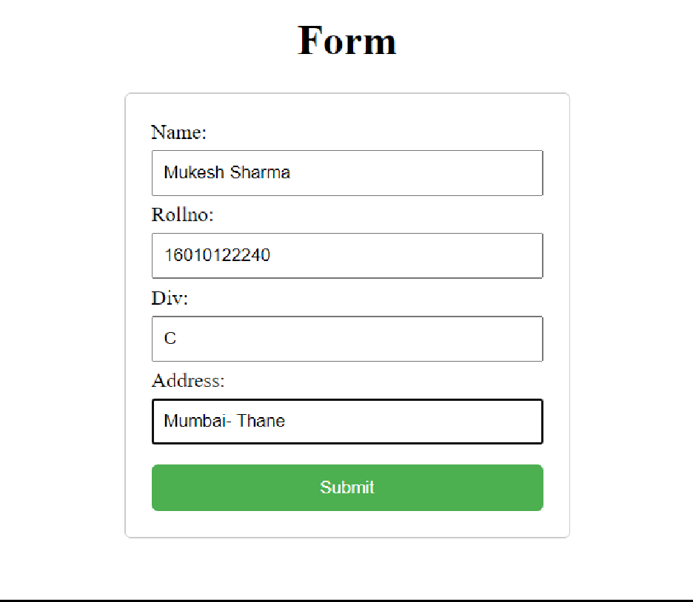

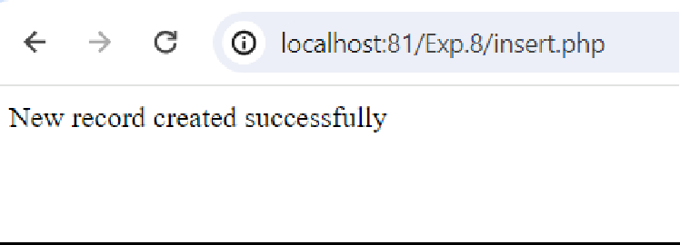

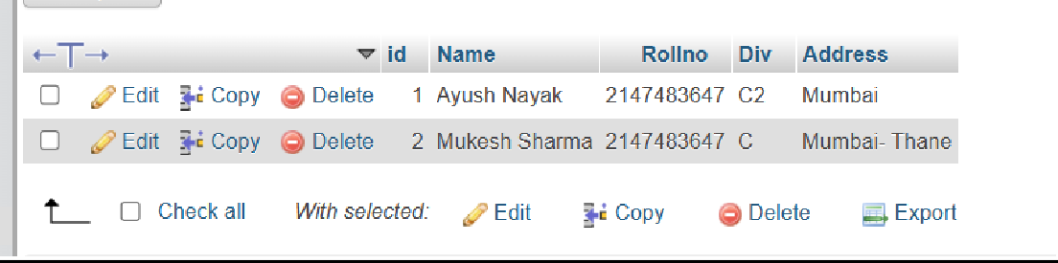

# Post Lab Descriptive Questions:

1. **What are the advantages of server side technologies that you used? Answer:**

The server-side technologies used (PHP and MySQL) offer several advantages:

* + Dynamic Content Generation: Server-side technologies allow for the generation of dynamic content based on user input or database queries. This enables the creation of interactive and personalized web experiences.
  + Database Integration: Server-side technologies like PHP can seamlessly integrate with databases such as MySQL, allowing for efficient storage, retrieval, and manipulation of data. This facilitates the development of data-driven web applications.
  + Security: Server-side technologies provide mechanisms for implementing security measures such as input validation, data sanitization, and user authentication. This helps protect against common web security threats such as SQL injection and cross-site scripting (XSS).
  + Scalability: Server-side technologies can handle large volumes of traffic and scale to accommodate growing user bases. Additionally, they support the implementation of caching mechanisms and optimization techniques to improve performance.
  + Cross-Platform Compatibility: PHP, in particular, is platform-independent and can run on various operating systems, including Windows, Linux, and macOS. This ensures that web applications developed using PHP can be deployed across different environments without significant modifications.
  + Community Support and Resources: PHP and MySQL have large and active developer communities, which means there are abundant resources, tutorials, and libraries available for developers. This facilitates rapid development and troubleshooting of web applications.
  + Cost-Effectiveness: PHP is an open-source scripting language, and MySQL is an open- source relational database management system (RDBMS). This means they are freely available for use, making them cost-effective options for web development projects.
  + Flexibility: Server-side technologies provide flexibility in terms of application architecture and design. Developers have the freedom to choose from various frameworks, libraries, and tools to suit their project requirements and coding preferences.

# Which function is used for database connectivity in PHP?

<?php

$servername = "localhost";

$username = "root";

$password = "";

$dbname = "school";

$conn = new mysqli($servername, $username, $password, $dbname); if ($conn->connect_error) {

die("Connection failed: " . $conn->connect_error);

}

if(isset($_POST['submit'])) {

$name = $_POST['name'];

$rollno = $_POST['rollno'];

$div = $_POST['div'];

$address = $_POST['address'];

$name = mysqli_real_escape_string($conn, $name);

$rollno = mysqli_real_escape_string($conn, $rollno);

$div = mysqli_real_escape_string($conn, $div);

$address = mysqli_real_escape_string($conn, $address);

$sql = "INSERT INTO students (Name, Rollno, `Div`, `Address`) VALUES ('$name', '$rollno', '$div', '$address')";

if ($conn->query($sql) === TRUE) {

echo "New record created successfully";

} else {

echo "Error: " . $sql . "<br>" . $conn->error;

}

}

$conn->close();

?>

1. **How would you redirect the page in PHP?**

if ($conn->query($sql) === TRUE) {

echo "New record created successfully";

} else {

echo "Error: " . $sql . "<br>" . $conn->error;

}

}

$conn->close();

?>